Mini Project 2

Semantic Segmentation on Pascal VOC 2007: Comparative Evaluation of U-Net, SAM 2, and Ablation-Driven Model Behaviour

Rohan Pancharatnam
April 2026

Word Count: 2578

Project submitted in partial fulfilment of SHBT 261: Artificial Intelligence in Medicine at Harvard Medical School

Table of Contents
1. Introduction 3
2. Methods and Model Architectures 4
2.1 Dataset preparation 4
2.3 Training protocol 4
2.4 Evaluation metrics 5
2.5 Ablation study design 5
3. Results 5
3.1 Quantitative model comparison 5
3.2 Class-wise behaviour and confusion analysis 6
3.3 HD95 and human-class spatial evaluation 7
3.4 Qualitative segmentation mosaics 8
3.5 U-Net versus SAM 2 qualitative comparison 8
4. Discussion: Interpretations and lessons learned 9
5. Conclusion 11
5. References 11

1. Introduction

Semantic segmentation is a dense prediction task in computer vision in which every pixel in an image is assigned a semantic class label. Unlike image classification, which produces a single global label, or object detection, which localises objects using bounding boxes, semantic segmentation requires both precise spatial localisation and accurate semantic understanding, making it a foundational task in applications such as autonomous driving, robotics, scene parsing, and medical imaging. ¹˒²

The Pascal VOC 2007 dataset remains a widely used benchmark for semantic segmentation because it contains diverse real-world scenes spanning 20 foreground object categories alongside a background class. Its variability in object scale, pose, occlusion, and scene complexity makes it particularly suitable for evaluating how segmentation models behave under realistic visual conditions. At the same time, its relatively limited dataset size provides an ideal setting for studying the effects of architectural choices, transfer learning, and regularisation strategies.

This project is especially motivated by the contrast between fully learned dense segmentation architectures, such as U-Net, and prompt-driven foundation models, such as Segment Anything Model 2 (SAM 2). U-Net learns global scene semantics through end-to-end optimisation, whereas SAM-based models perform prompt-guided instance discovery using large-scale prior visual knowledge. ²˒³ Comparing these paradigms offers insight not only into raw segmentation performance, but also into the broader distinction between scene-level semantic consistency and prompt-local boundary precision.

The aim of this project was therefore twofold: first, to benchmark U-Net and SAM 2 on Pascal VOC 2007 semantic segmentation, and second, to use controlled ablation studies to explain how data augmentation, loss function design, encoder depth, and pretraining influence segmentation quality, generalisation, and failure modes.

2. Methods and Model Architectures

2.1 Dataset preparation
The Pascal VOC 2007 semantic segmentation dataset was used for all experiments. This benchmark contains 20 foreground object classes and one background class; each paired with dense pixel-level mask annotations. In line with the project brief, the original validation split was repurposed as the final test set, while the original test split was excluded from analysis. All RGB images and their corresponding masks were resized to 256 × 256 pixels, which provided a standardised input size while maintaining sufficient spatial detail for object boundaries and multi-instance scenes. The original 21-class mask encoding was preserved throughout preprocessing and ignored boundary pixels were retained using the standard ignore index of 255. After preprocessing, the validation set used for all final evaluations contained 213 images.

2.2 Model architectures
The primary learned segmentation model was a U-Net with a ResNet18 encoder backbone, implemented using segmentation_models_pytorch. This architecture was chosen because its encoder-decoder design combines hierarchical semantic feature extraction with skip-connected spatial refinement, allowing recovery of fine object boundaries while preserving global scene context.
To satisfy the requirement for additional models and modifications, four controlled ablation variants were also developed. The augmented U-Net introduced paired image-mask transformations to improve generalisation. The Dice-loss U-Net replaced the baseline cross-entropy objective with a region-overlap loss. The ResNet50 U-Net increased encoder depth to investigate the effect of model capacity, and the scratch U-Net removed ImageNet pretraining to directly quantify the contribution of transfer learning.

In parallel, SAM 2 was evaluated as a prompt-based zero-shot segmentation model. Unlike U-Net, SAM 2 was not trained on Pascal VOC and instead used point-prompt inference to generate segmentation masks from pretrained foundation-level visual priors. This allowed direct comparison between global scene-level semantic segmentation and prompt-local instance discovery.

2.3 Training protocol
All learned U-Net variants were trained for 20 epochs on CUDA using the Adam optimiser with a learning rate of 1 × 10⁻⁴. The baseline, augmentation, encoder-depth, and scratch experiments used pixel-wise cross-entropy loss, whereas the Dice-loss ablation replaced this objective with Dice coefficient optimisation to better align the training objective with overlap-based segmentation metrics.
ImageNet-pretrained encoder weights were used in all learned models except the scratch ablation. Training and inference speed were also compared qualitatively across all model variants to satisfy the brief’s requirement for computational comparison.

2.4 Evaluation metrics
Model performance was assessed using the full set of required segmentation metrics, including Pixel Accuracy, Mean Intersection-over-Union (mIoU), Mean Dice coefficient, 95th percentile Hausdorff distance (HD95), per-class IoU, and per-class accuracy. In addition, both a raw pixel-level confusion matrix and a foreground-normalised confusion matrix were generated to better interpret inter-class confusion and semantic collapse.

Because the brief explicitly emphasised qualitative human-class evaluation, focused analysis was additionally performed on the person class, including top-three best and worst examples, multi-image mosaics, and a final easy-versus-difficult comparison figure spanning the baseline U-Net, Dice-loss U-Net, and SAM 2.

2.5 Ablation study design
The ablation framework was designed not simply to compare numerical performance, but to explain why segmentation quality changed under controlled architectural and optimisation perturbations. Specifically, augmentation was used to test generalisation, Dice loss to test overlap-optimised learning, ResNet50 to test encoder capacity scaling, and scratch training to quantify the dependence of dense segmentation on transfer learning priors.

3. Results

3.1 Quantitative model comparison
The overall quantitative comparison of all segmentation models and ablation variants is summarised in Table 1. The baseline U-Net with a ResNet18 encoder provided a strong balanced reference, achieving a Pixel Accuracy of 0.7874, mIoU of 0.0901, and Mean Dice of 0.1107. Introducing paired augmentation produced the best validation generalisation, increasing Pixel Accuracy to 0.8113, alongside modest gains in mIoU (0.1049) and Mean Dice (0.1278).
The strongest overlap-based segmentation performance was achieved by the Dice-loss U-Net, which improved mIoU to 0.1414 and Mean Dice to 0.1800, representing the best region-level segmentation quality among all learned models. Although its Pixel Accuracy decreased to 0.6883, the higher overlap metrics indicate that Dice optimisation better aligned the training objective with segmentation mask quality.
Increasing encoder depth with a ResNet50 U-Net did not improve performance relative to the baseline, with Pixel Accuracy of 0.7643, mIoU of 0.0898, and Mean Dice of 0.1114, suggesting that additional capacity alone was not beneficial in this limited-data setting. In contrast, the scratch U-Net demonstrated the importance of transfer learning, with performance dropping to 0.7222 Pixel Accuracy and 0.0406 mIoU, confirming that pretrained semantic priors were critical for stable dense prediction.
SAM 2 was evaluated as a prompt-based zero-shot segmentation model and therefore is not directly comparable using full-scene semantic metrics. However, in person-class prompt experiments it achieved single-instance IoU values up to 0.970, highlighting strong prompt-guided boundary precision in favourable scenes.

Table 1. Quantitative comparison of segmentation models and ablation variant

Model | Pixel Accuracy | mIoU | Mean Dice | Training Speed | Main Lesson
Baseline U-Net (ResNet18 CE) | 0.7874 | 0.0901 | 0.1107 | fast | balanced baseline
Augmented U-Net | 0.8113 | 0.1049 | 0.1278 | slightly slower | best generalisation
Dice-loss U-Net | 0.6883 | 0.1414 | 0.18 | fast | best overlap
ResNet50 U-Net | 0.7643 | 0.0898 | 0.1114 | slowest | larger encoder not beneficial
Scratch U-Net | 0.7222 | 0.0406 | 0.051 | fastest | pretraining critical
SAM 2 (person prompt) | qualitative | prompt IoU up to 0.970 | best single instance | no training | excellent boundaries, weak semantics
Table 1. Quantitative comparison of all segmentation models and ablation variants. Augmentation improved generalisation, Dice loss produced the best overlap-based performance, and scratch training highlighted the importance of pretraining.

3.2 Class-wise behaviour and confusion analysis
To better understand class-specific strengths and weaknesses, a foreground-normalised confusion matrix was generated for the baseline U-Net (Figure 1). This revealed substantial semantic collapse into the person class, which acted as a dominant attractor category for multiple visually heterogeneous foreground objects. Classes including bicycles, chairs, bottles, and several animals were frequently misclassified as person despite correct foreground localisation.

This finding explains the divergence between relatively preserved Pixel Accuracy and weaker overlap-based metrics. The model successfully learned coarse object localisation, but often failed to preserve fine-grained inter-class semantics, particularly for rare, thin, or structurally ambiguous categories.

Per-class evaluation reinforced this observation. The person class remained one of the strongest semantic categories, with substantially higher class-wise performance than sparse classes such as bicycle, bottle, plant, and train, many of which approached near-zero IoU or class accuracy.

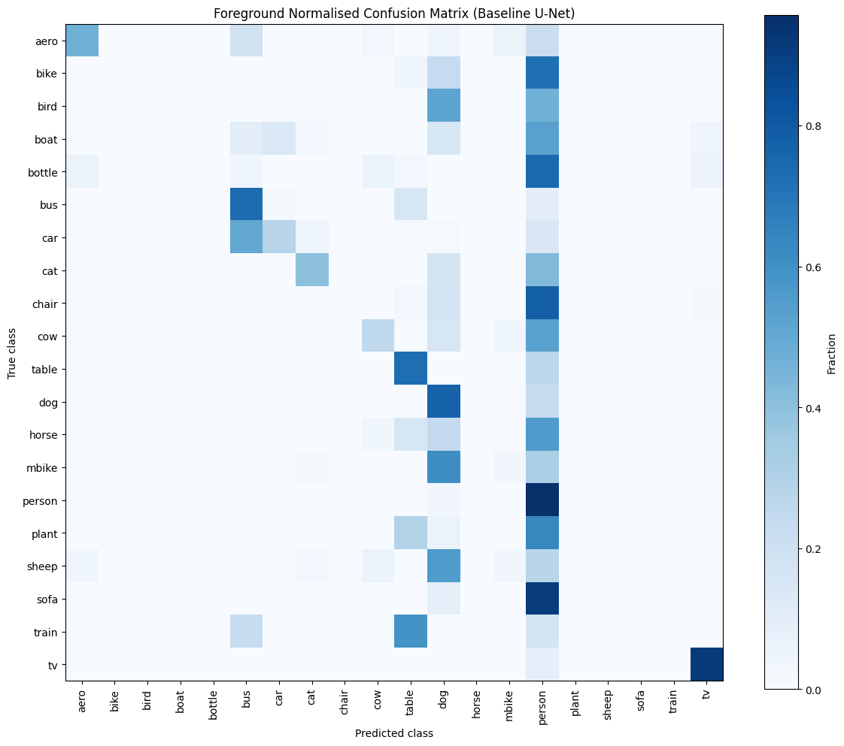
Figure 1. Foreground-normalised confusion matrix for the baseline U-Net
Multiple semantic categories collapsed into the person class, demonstrating preserved coarse foreground localisation but weak fine-grained semantic separation. This supports the observed discrepancy between relatively stable pixel accuracy and low overlap-based metrics.

3.3 HD95 and human-class spatial evaluation
Spatial boundary fidelity was further evaluated using the 95th percentile Hausdorff distance (HD95) on the person class, as explicitly required by the brief. For the baseline U-Net, the median person-class HD95 was 71.8131, indicating that while global silhouettes were generally preserved, boundary deviations remained substantial in difficult scenes involving occlusion, truncation, or multiple adjacent people.
This metric was particularly useful in separating visually acceptable overlap from true boundary precision. Cases with strong Dice scores but elevated HD95 often reflected silhouette agreement with local edge distortion, especially around hair, limbs, and fine extremities.

3.4 Qualitative segmentation mosaics
Mosaic-style qualitative comparisons were generated to satisfy the brief’s requirement for side-by-side visualisation of segmentation behaviour (Figure 2). In the top three best person-class predictions, the baseline and Dice-loss U-Net variants consistently preserved the full silhouette with strong semantic continuity and limited background leakage. In contrast, the worst three examples showed fragmentation, missed extremities, and semantic leakage into neighbouring structures.
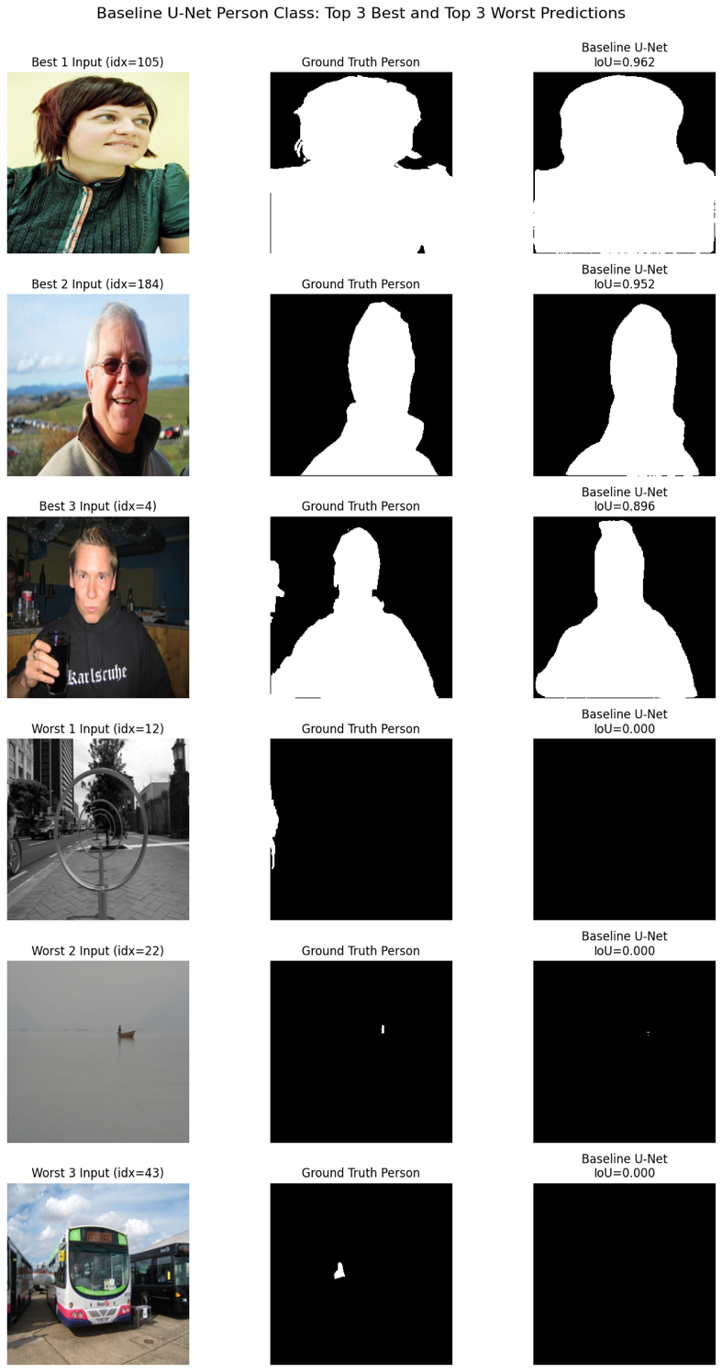

Figure 2. Mosaic-style best-versus-worst person-class predictions
Mosaic comparison of the top three best and top three worst baseline U-Net person-class predictions. Best examples preserve full-body silhouette continuity, whereas failure cases demonstrate fragmentation, missed extremities, and semantic leakage into adjacent foreground structures.

Figure 2 demonstrates strong qualitative heterogeneity in person-class performance. In the top three examples, the baseline U-Net preserves full silhouette continuity with high overlap and minimal background leakage, particularly for large, centred foreground humans. In contrast, the worst three examples reveal a clear failure mode for small-object semantic recall, where distant or partially occluded human instances are completely missed despite correct ground-truth presence. This strongly supports the quantitative class-wise findings and highlights scale sensitivity as a key weakness of the baseline architecture.

3.5 U-Net versus SAM 2 qualitative comparison
The strongest qualitative comparison between learned dense segmentation and prompt-based foundation segmentation is shown in the easy-versus-difficult hero comparison figure. In the easy isolated foreground example, all models performed strongly, with SAM 2 producing exceptionally clean boundaries. However, in the difficult multi-person example, both the baseline and Dice-loss U-Net preserved the full semantic scene structure, whereas SAM 2 often recovered only the prompt-local head or torso region.

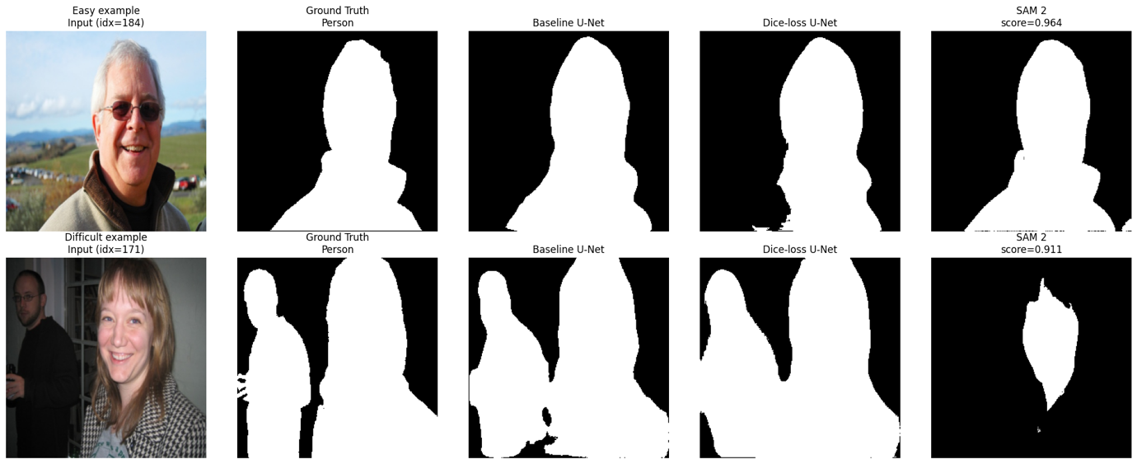
This contrast highlights one of the central findings of the study: U-Net variants preserve scene-level semantic consistency, whereas SAM 2 excels in prompt-local boundary precision but degrades in multi-instance semantic settings (Figure 3).
Figure 3. Side-by-side comparison between ground truth and predictions for easy and difficult person-class examples across baseline U-Net, Dice-loss U-Net, and SAM 2.

3.6 Ablation study outcomes
The controlled ablation experiments provided direct insight into the determinants of segmentation quality. Data augmentation produced the strongest validation generalisation, improving Pixel Accuracy and modestly improving overlap metrics. Dice loss yielded the strongest region-level segmentation quality, producing the best Mean Dice and mIoU across all learned models. In contrast, increasing encoder size from ResNet18 to ResNet50 did not improve performance, suggesting that model capacity was not the limiting factor. Finally, removing ImageNet pretraining substantially reduced performance, demonstrating that transfer learning priors were critical for stable semantic segmentation on Pascal VOC 2007.
These ablation findings fully satisfy the brief’s requirement to compare model size, augmentation, loss functions, and pretraining strategies, while also providing interpretable lessons about generalisation and optimisation behaviour.

4. Discussion: Interpretations and lessons learned

The comparative evaluation of U-Net variants and SAM 2 demonstrated that segmentation quality was determined less by raw model size and more by alignment between model inductive bias, optimisation objective, and task structure. Across all learned dense models, the baseline U-Net provided the strongest balance between semantic continuity, stable pixel accuracy, and computational efficiency, supporting the original U-Net principle that skip-connected encoder-decoder architectures are highly effective for dense localisation tasks.¹ The Dice-loss variant improved overlap-based metrics by directly optimising region agreement, but qualitative mosaics showed that this often introduced boundary over-extension and reduced local specificity. This reinforces an important methodological lesson: the loss function shapes not only scalar performance, but also the visual failure mode of the segmentation model. Recent methodological guidance on segmentation evaluation similarly emphasises that Dice and IoU capture region overlap but do not fully represent contour fidelity or downstream relevance.⁴

The confusion analysis revealed that the baseline U-Net learned foreground localisation before reliable semantic separation. The foreground-normalised confusion matrix showed widespread collapse of multiple object classes into the person label, suggesting that articulated and visually heterogeneous foreground structures can act as semantic attractors during optimisation. This explains why Pixel Accuracy remained relatively preserved despite weak mIoU. In effect, the model frequently recognised that a foreground object existed while failing to preserve precise class identity. By contrast, the strong diagonal retention for the tv class suggests that objects with stable morphology and highly consistent geometry are easier for compact encoder-decoder models to retain semantically. This observation aligns with broader segmentation evaluation guidance that warns against interpreting global accuracy metrics in isolation, particularly under class imbalance and heterogeneous object morphology. ⁴

The inclusion of HD95 was particularly valuable in separating visually plausible overlap from true boundary fidelity. Even cases with acceptable Dice scores showed elevated Hausdorff distances when fine extremities, hair contours, or neighbouring people were present. This reinforces the key lesson that good overlap does not guarantee precise boundaries, an issue of particular importance in biomedical and clinical segmentation tasks such as tumour margins, vessel tracing, or surgical planning. Müller et al. similarly argue that Hausdorff-based metrics provide critical complementary information where edge precision influences downstream decision-making.⁴

The ablation studies provided the clearest mechanistic insights of the project. Data augmentation improved validation generalisation, indicating that Pascal VOC 2007’s limited size benefits substantially from stronger invariance priors. Dice loss improved overlap, confirming that overlap-aware optimisation better aligns with segmentation evaluation metrics than cross-entropy alone. However, increasing encoder depth from ResNet18 to ResNet50 did not improve performance, suggesting that model capacity was not the limiting factor in this data regime. Most importantly, the poor performance of the scratch U-Net established that transfer learning priors are critical for stable dense segmentation, especially when labelled pixel-wise datasets remain modest in scale. This is one of the most clinically transferable lessons from the project, since labelled medical segmentation datasets are frequently small and expensive to annotate.

The comparison with SAM 2 highlighted a broader conceptual distinction between prompt-based foundation segmentation and dense semantic segmentation. In isolated single-person scenes, SAM 2 consistently produced the cleanest boundaries, reflecting the strength of large-scale visual pretraining for local instance delineation. ³ However, its failure in multi-person scenes demonstrated that prompt-based segmentation remains fundamentally dependent on instance-level prompting assumptions rather than scene-level semantic consistency. This finding is highly consistent with recent benchmarking studies showing that vanilla SAM underperforms specialised U-Net-style architectures on semantic and medical segmentation tasks requiring dense global consistency. ⁵

The strongest overall lesson learned is that segmentation evaluation is intrinsically multidimensional. Pixel Accuracy, Dice, IoU, HD95, confusion matrices, and qualitative mosaics each exposed different behavioural properties that would have been invisible in isolation. The project therefore reinforces a broader principle for AI in medicine: model assessment must prioritise failure mode analysis and task-specific interpretability over single benchmark scores alone. In clinically meaningful settings, understanding why a model fails is often more important than marginal improvements in average overlap metrics.

5. Conclusion
This project demonstrated that semantic segmentation performance depends strongly on the interaction between architectural design, optimisation objective, and dataset scale. Across all learned models, the baseline and augmented U-Net variants provided the strongest balance between semantic consistency, computational efficiency, and generalisation. Dice-loss optimisation improved overlap-based metrics, while transfer learning proved essential for stable dense prediction in limited-data settings.
The comparison with SAM 2 highlighted an important conceptual distinction: prompt-based foundation models excel at precise local boundary delineation, whereas task-specific U-Net architectures remain stronger for scene-level semantic consistency, particularly in multi-instance environments. Overall, the study reinforces that robust segmentation evaluation requires multidimensional analysis combining scalar metrics, confusion behaviour, boundary distances, qualitative mosaics, and controlled ablations.

5. References

- Long J, Shelhamer E, Darrell T. Fully convolutional networks for semantic segmentation. In: Proceedings of the IEEE Conference on Computer Vision and Pattern Recognition. 2015. p. 3431-3440.
- Ronneberger O, Fischer P, Brox T. U-Net: convolutional networks for biomedical image segmentation. In: Medical Image Computing and Computer-Assisted Intervention (MICCAI). Lecture Notes in Computer Science. 2015;9351:234-241.
- Kirillov A, Mintun E, Ravi N, Mao H, Rolland C, Gustafson L, Xiao T, Whitehead S, Berg AC, Lo WY, Dollár P, Girshick R. Segment anything. In: Proceedings of the IEEE/CVF International Conference on Computer Vision (ICCV). 2023. p. 4015-4026.
- Müller D, Soto-Rey I, Kramer F. Towards a guideline for evaluation metrics in medical image segmentation. BMC Res Notes. 2022;15:210.
- He S, Bao R, Li J, Stout J, Bjornerud A, Grant PE, et al. Computer-vision benchmark Segment Anything Model (SAM) in medical images: accuracy in 12 datasets. arXiv. 2023:2304.09324.

